FIELD TRIPS to HorsePlay / Spring 2026
Life Skills, Special Education students and Other groups

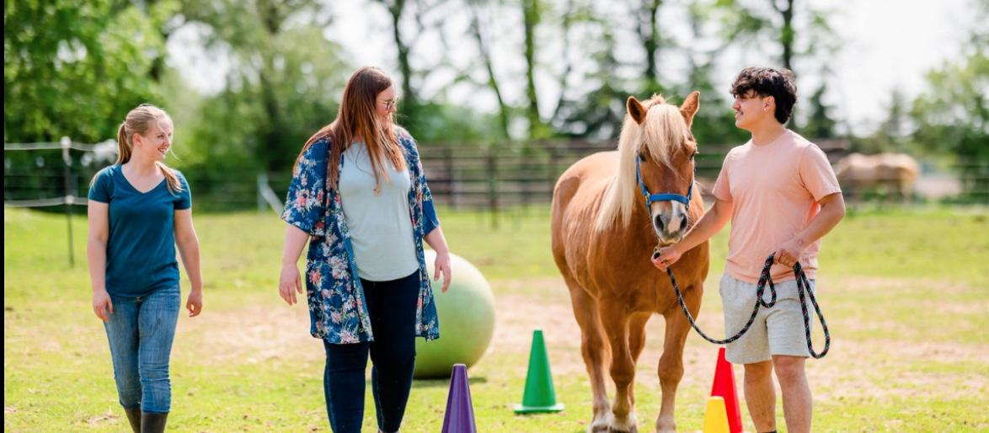
HVHP offers structured, ground-based, educational programs with horses that support communication, emotional regulation, cooperation, and confidence-building in a calm, inclusive environment. These are non-riding experiences, fully facilitated by staff.

Programs take place on our farm and in a covered arena, allowing visits to run reliably in a variety of weather conditions, which is especially helpful for school scheduling.

What Participants Experience
- Social-emotional learning
- Functional communication
- Teamwork and peer interaction
- Emotional awareness and self-regulation
- Observation & problem-solving

Program Highlights
- Ground-based, non-riding activities
- Fully facilitated
- Small group sizes
- Calm, gentle ponies & horses
- Covered arena for all-weather activity

Program Details & Pricing
2-Hour field trip: $35 per student Half-day: $60 per student
Teachers & aides attend at no cost
Spring 2026 (April - June) - in Kerhonkson, NY

Contact: Cori Nichols, Founder & Facilitator
(845) 616 - 3608
Cori@HudsonValleyHorsePlay.com

